**Group A: Assignment No:01**

**Problem Statement:**

Consider telephone book database of N clients. Make use of a hash table implementation to quickly look up client‘s telephone Number. Make Use of two Collision Techniques and Compare them using number of Comparisons required to find a set of telephone numbers.

**Program:**

**1. Python program File Name LinearProbing.py**

**# Program to implement Hashing with Linear Probing**

from Record import Record

class hashTable:

**# initialize hash Table**

    def __init__(self):

        self.size = int(input("Enter the Size of the hash table : "))

**# initialize table with all elements 0**

        self.table = list(None for i in range(self.size))

        self.elementCount = 0

        self.comparisons = 0

**# method that checks if the hash table is full or not**

    def isFull(self):

        if self.elementCount == self.size:

            return True

        else:

            return False

**# method that returns position for a given element**

    def hashFunction(self, element):

        return element % self.size

**# method that inserts element into the hash table**

    def insert(self, record):

**# checking if the table is full**

        if self.isFull():

            print("Hash Table Full")

            return False

        isStored = False

        position = self.hashFunction(record.get_number())

**# checking if the position is empty**

        if self.table[position] == None:

            self.table[position] = record

            print("Phone number of " + record.get_name() + " is at position " + str(position))

            isStored = True

            self.elementCount += 1

**# collision occured hence we do linear probing**

        else:

            print("Collision has occured for " + record.get_name() + "'s phone number at position " + str(position) + " finding new Position.")

            while self.table[position] != None:

                position += 1

                if position >= self.size:

                    position = 0

            self.table[position] = record

            print("Phone number of " + record.get_name() + " is at position " + str(position))

            isStored = True

            self.elementCount += 1

        return isStored

**# method that searches for an element in the table returns position of element if found else returns False**

    def search(self, record):

        found = False

        position = self.hashFunction(record.get_number())

        self.comparisons += 1

        if(self.table[position] != None):

            if(self.table[position].get_name() == record.get_name() and self.table[position].get_number() == record.get_number()):

                isFound = True

                print("Phone number found at position {} ".format(position) + " and total comparisons are " + str(1))

                return position

**# if element is not found at position returned hash function**

            else:

                position += 1

                if position >= self.size-1:

                    position = 0

                while self.table[position] != None or self.comparisons <= self.size:

                    if(self.table[position].get_name() == record.get_name() and self.table[position].get_number() == record.get_number()):

                        isFound = True

                        i=0

                        i = self.comparisons + 1

                        print("Phone number found at position {} ".format(position) + " and total comparisons are " + str(i) )

                        return position

                    position += 1

                    print(position)

                    if position >= self.size-1:

                        position = 0

                    print(position)

                    self.comparisons += 1

                    print(self.comparisons)

                if isFound == False:

                    print("Record not found")

                    return false

**# method to display the hash table**

    def display(self):

        print("\n")

        for i in range(self.size):

            print("Hash Value: "+str(i) + "\t\t" + str(self.table[i]))

        print("The number of phonebook records in the Table are : " + str(self.elementCount))

**2. Python Program File Name : Record.py**

class Record:

    def __init__(self):

        self._name = None

        self._number = None

    def get_name(self):

        return self._name

    def get_number(self):

        return self._number

    def set_name(self,name):

        self._name = name

    def set_number(self,number):

        self._number = number

    def __str__(self):

        record = "Name: "+str(self.get_name())+"\t"+"\tNumber: "+str(self.get_number())

        return record

**3.  Python Program File Name : DoubleHashing.py**

from Record import Record

class doubleHashTable:

**# initialize hash Table**

    def __init__(self):

        self.size = int(input("Enter the Size of the hash table : "))

**# initialize table with all elements 0**

        self.table = list(None for i in range(self.size))

        self.elementCount = 0

        self.comparisons = 0

**# method that checks if the hash table is full or not**

    def isFull(self):

        if self.elementCount == self.size:

            return True

        else:

            return False

**# First hash function**

    def h1(self, element):

        return element % self.size

**# Second hash function**

    def h2(self, element):

        return 5-(element % 5)

**# method to resolve collision by double hashing method**

    def doubleHashing(self, record):

        posFound = False

**# limit variable is used to restrict the function from going into infinite loop**

**# limit is useful when the table is 80% full**

        limit = self.size

        i = 1

**# start a loop to find the position**

        while i <= limit:

**# calculate new position by quadratic probing**

            newPosition = (self.h1(record.get_number()) + i*self.h2(record.get_number())) % self.size

**# if newPosition is empty then break out of loop and return new Position**

            if self.table[newPosition] == None:

                posFound = True

                break

            else:

**# as the position is not empty increase i**

                i += 1

        return posFound, newPosition

**# method that inserts element inside the hash table**

    def insert(self, record):

**# checking if the table is full**

        if self.isFull():

            print("Hash Table Full")

            return False

        posFound = False

        position = self.h1(record.get_number())

**# checking if the position is empty**

        if self.table[position] == None:

**# empty position found , store the element and print the message**

            self.table[position] = record

            print("Phone number of " + record.get_name() + " is at position " + str(position))

            isStored = True

            self.elementCount += 1

**# If collision occured**

        else:

            print("Collision has occured for " + record.get_name() + "'s phone number at position " + str(position) + " finding new Position.")

            while not posFound:

                posFound, position = self.doubleHashing(record)

                if posFound:

                    self.table[position] = record

                    print(self.table[position])

                    self.elementCount += 1

                    print(position)

                    print(posFound)

                    print("Phone number of " + record.get_name() + " is at position " + str(position))

        return posFound

**# searches for an element in the table and returns position of element if found else returns False**

    def search(self, record):

        found = False

        position = self.h1(record.get_number())

        self.comparisons += 1

        if(self.table[position] != None):

            if(self.table[position].get_name() == record.get_name()):

                print("Phone number found at position {}".format(position) + " and total comparisons are " + str(1))

                return position

**# if element is not found at position returned hash function**

**# then we search element using double hashing**

            else:

                limit = self.size

                i = 1

                newPosition = position

**# start a loop to find the position**

                while i <= limit:

**# calculate new position by double Hashing**

                    position = (self.h1(record.get_number()) + i*self.h2(record.get_number())) % self.size

                    self.comparisons += 1

**# if element at newPosition is equal to the required element**

                    if(self.table[position] != None):

                        if self.table[position].get_name() == record.get_name():

                            found = True

                            break

                        elif self.table[position].get_name() == None:

                            found = False

                            break

                        else:

**# as the position is not empty increase i**

                            i += 1

            if found:

                print("Phone number found at position {}".format(position) + " and total comparisons are " + str(i+1))

return position

            else:

                print("Record not Found")

                return found

**# method to display the hash table**

    def display(self):

        print("\n")

        for i in range(self.size):

            print("Hash Value: "+str(i) + "\t\t" + str(self.table[i]))

        print("The number of phonebook records in the Table are : " + str(self.elementCount))

**4.  Python Program File Name : main.py**

from LinearProbing import hashTable

from Record import Record

from DoubleHashing import doubleHashTable

def input_record():

    record = Record()

    name = input("Enter Name:")

    number = int(input("Enter Number:"))

    record.set_name(name)

    record.set_number(number)

    return record

choice1 = 0

while(choice1 != 3):

    print("************************")

    print("1. Linear Probing      *")

    print("2. Double Hashing      *")

    print("3. Exit                *")

    print("************************")

    choice1 = int(input("Enter Choice"))

    if choice1>3:

        print("Please Enter Valid Choice")

    if choice1 == 1:

        h1 = hashTable()

        choice2 = 0

        while(choice2 != 4):

            print("************************")

            print("1. Insert              *")

            print("2. Search              *")

            print("3. Display             *")

            print("4. Back                *")

            print("************************")

            choice2 = int(input("Enter Choice"))

            if choice2>4:

                print("Please Enter Valid Choice")

            if(choice2==1):

                record = input_record()

                h1.insert(record)

            elif(choice2 == 2):

                record = input_record()

                position = h1.search(record)

            elif(choice2 == 3):

                h1.display()

    elif choice1 == 2:

        h2 = doubleHashTable()

        choice2 = 0

        while(choice2 != 4):

            print("************************")

            print("1. Insert              *")

            print("2. Search              *")

            print("3. Display             *")

            print("4. Back                *")

            print("************************")

            choice2 = int(input("Enter Choice"))

            if choice2>4:

                print("Please Enter Valid Choice")

            if(choice2==1):

                record = input_record()

                h2.insert(record)

            elif(choice2 == 2):

                record = input_record()

                position = h2.search(record)

            elif(choice2 == 3):

                h2.display()

**Output: Linear Probing**

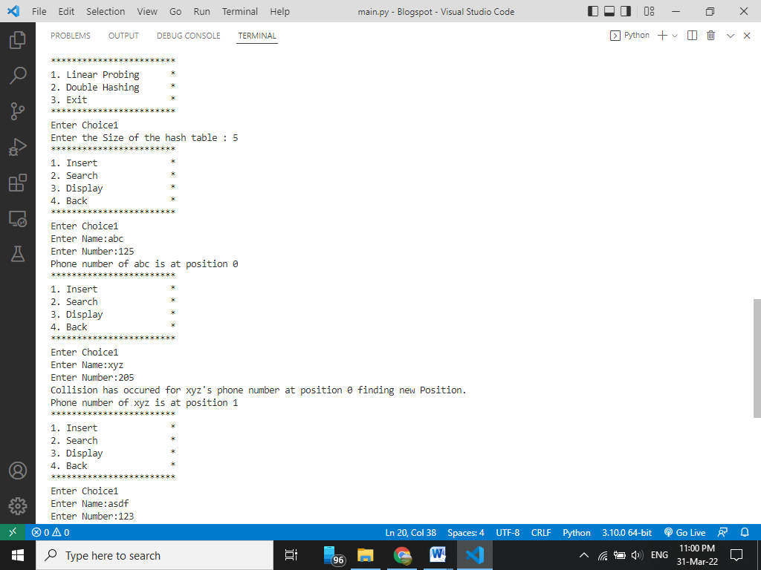

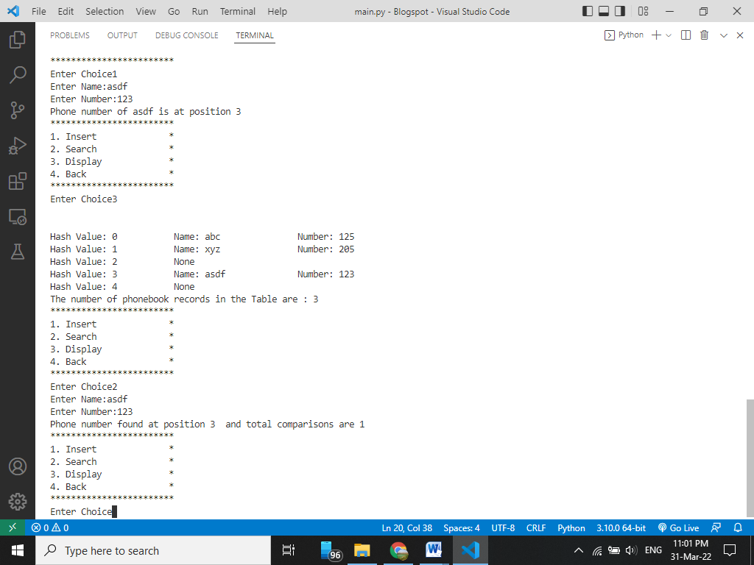

**Double Hashing**

